**Production Line Balancing - Manufacturing Sector**

GOKULNATH K & E24755

**Overview**

Production line balancing in the manufacturing sector ensures that work is evenly distributed across all stations to minimize idle time and maximize efficiency. It involves analyzing task durations, sequencing operations, and allocating resources to meet production goals without bottlenecks. Effective line balancing reduces cycle time, optimizes labor, and ensures smooth workflow, leading to higher productivity and lower costs. Data analysis helps identify inefficiencies and optimize the process.

**Objective**

1. **Maximizing Throughput:** Ensuring the highest possible production rate by balancing workloads across all stations to avoid bottlenecks and idle time.
2. **Minimizing Idle Time:** Reducing the downtime at each workstation by ensuring tasks are evenly distributed, enhancing overall efficiency.
3. **Improving Resource Utilization:** Optimizing labor and machine use to lower operational costs and increase productivity.
4. **Reducing Cycle Time:** Shortening the total time required to produce a unit by eliminating delays, improving the flow of tasks, and enhancing process speed.
5. **Achieving Flexibility:** Enabling the production line to adapt to changes in demand or product mix by having a well-balanced and easily adjustable system.
6. **Enhancing Quality Control:** Identifying imbalances that could lead to errors, improving the consistency and quality of the final product.
7. **Cost Optimization:** Reducing unnecessary costs associated with inefficiencies, overstaffing, and underutilized machinery.

**Assigned Task(s)**

* Production Line Balancing - Manufacturing Sector

**Task Details**

* **Task 20:** Production line balancing in manufacturing ensures an even distribution of tasks across workstations to minimize bottlenecks and idle time. Data analysis helps optimize efficiency, improve resource utilization, and reduce cycle time.
* **Status:** Completed
* **Details:** In the production line balancing analysis, the dataset was uploaded to Google Colab and processed using Pandas for data manipulation. Tasks were grouped by workstations to calculate the total processing time per workstation, allowing for the identification of bottlenecks. The maximum processing time across workstations was computed to serve as a benchmark for line balancing. Efficiency for each workstation was then calculated as a percentage, comparing the total time of each station to the most loaded one. Visualizations were created using Seaborn to display the workload distribution and workstation efficiency, providing clear insights into task allocation. This analysis helps optimize resource use, reduce bottlenecks, and improve overall production line efficiency.

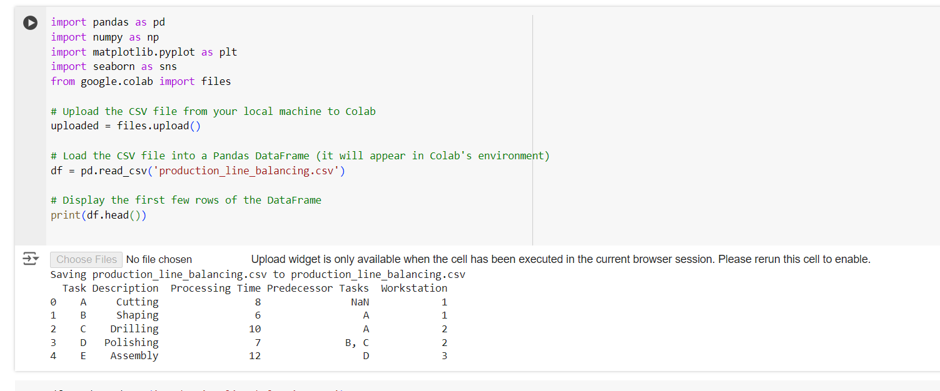

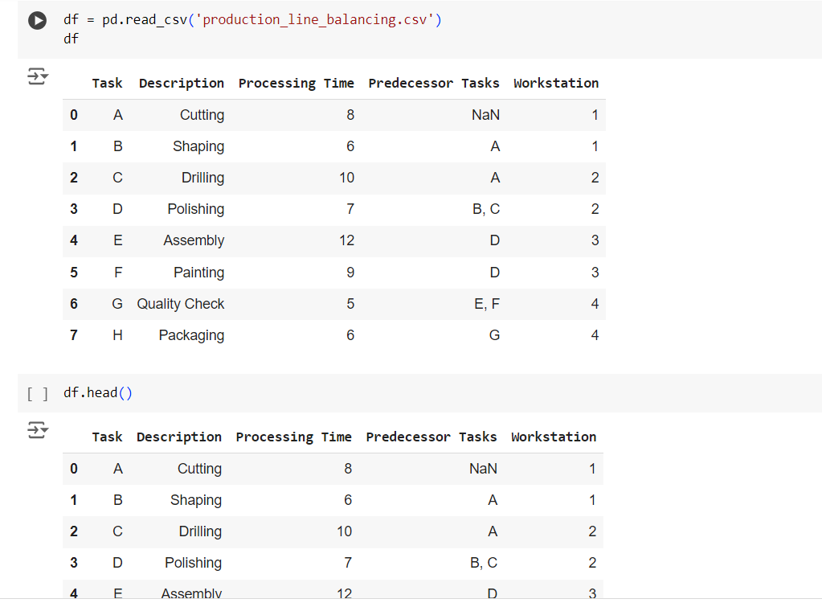

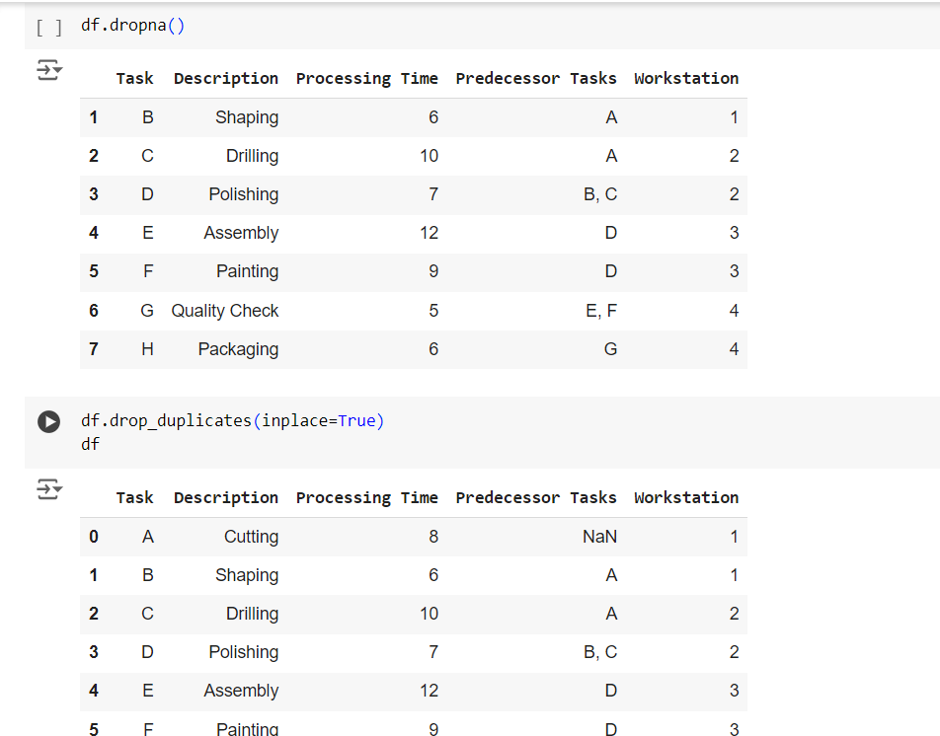

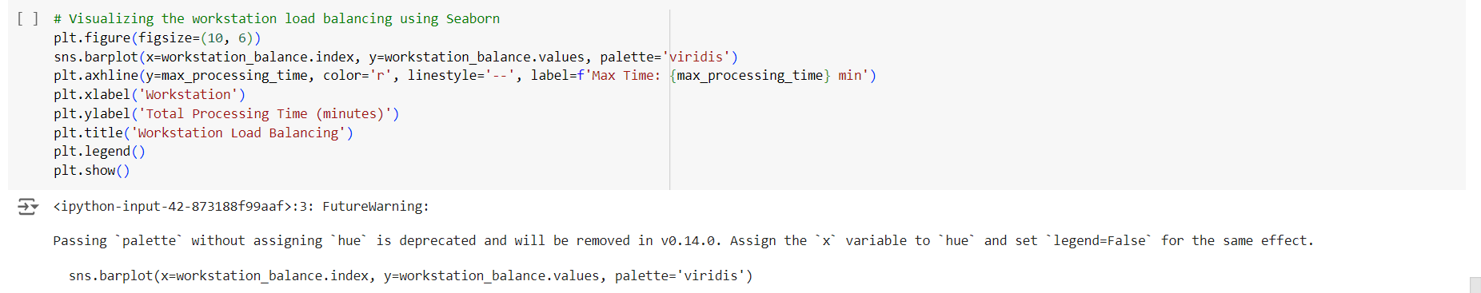

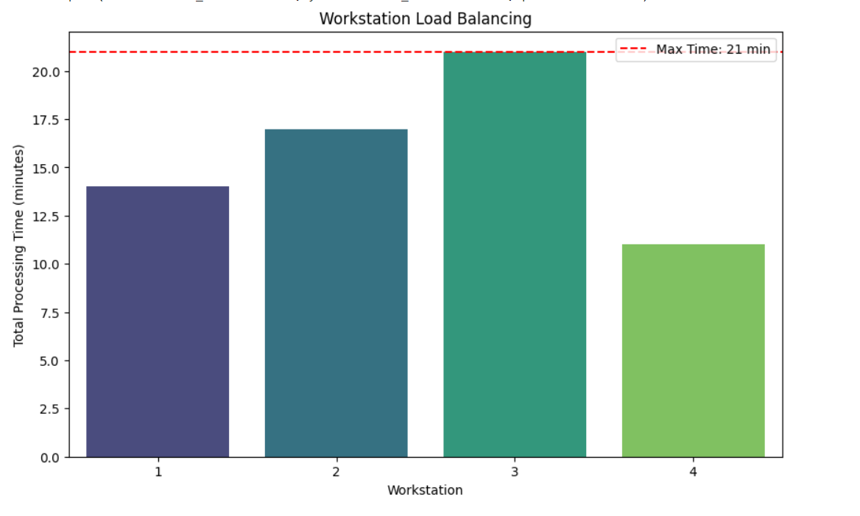

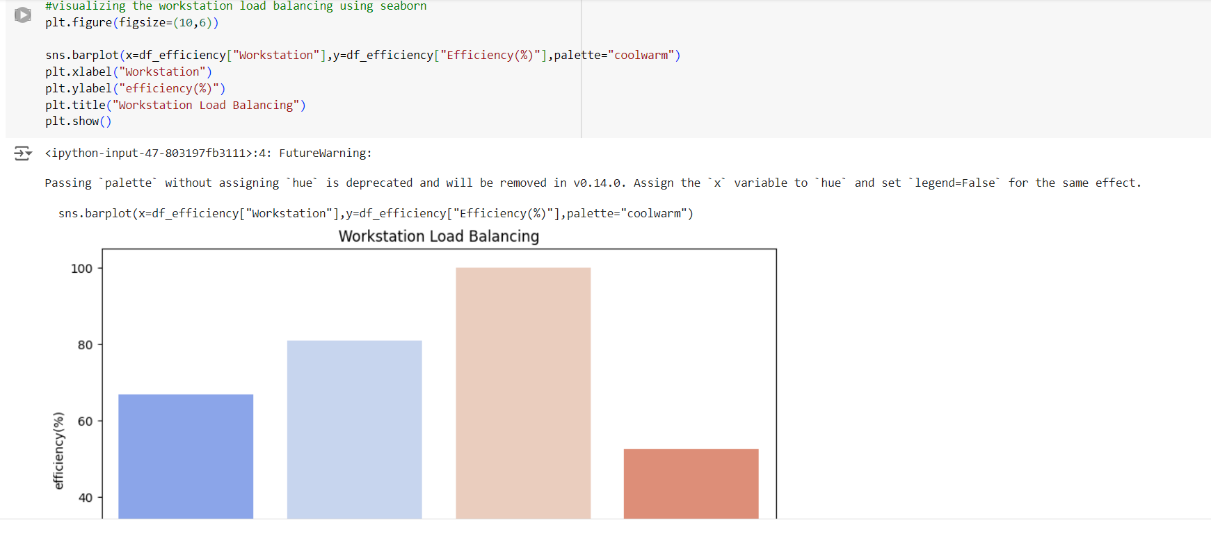

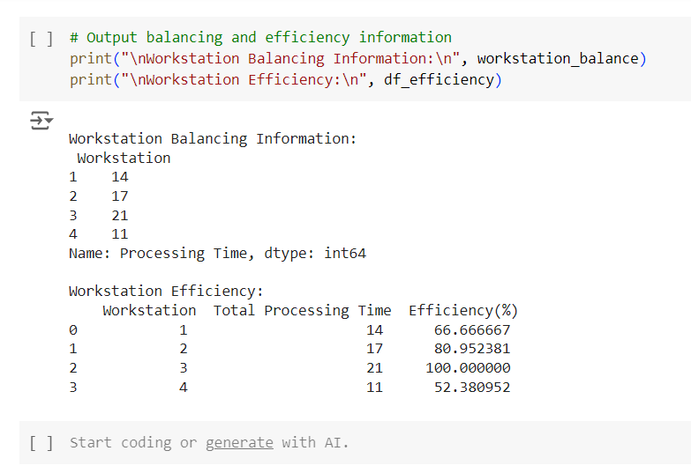

**Progress**

* **Accomplishments:** To achieve production line balancing in the manufacturing sector, start by collecting data on tasks, processing times, and workstation assignments. Analyze the workload for each workstation, calculate efficiency, and identify bottlenecks. Use visualizations to highlight imbalances and suggest task redistribution or resource adjustments for improved efficiency. Finally, implement changes and monitor performance to ensure continuous improvement in the production process.
* **Metrics: Total Processing Time per Workstation:** Measures the workload for each station to identify over/underutilized areas.
* **Maximum Processing Time:** Represents the highest load, showing the bottleneck workstation.
* **Workstation Efficiency:** Compares each station's load to the bottleneck, indicating performance as a percentage.
* **Workstation Load Balancing:** Visualizes task distribution to identify imbalances for optimization.

**Challenges and Solutions**

* **Challenges Faced:**

1. Some workstations may have too many tasks, leading to bottlenecks, while others remain underutilized.
2. When one workstation has a longer processing time, it delays the entire production line.
3. Inconsistent or outdated data makes it difficult to respond to production issues quickly.
4. Complex dependencies between tasks can disrupt the flow, especially if one task is delayed.
5. Machines or workers may be underutilized or overworked.

* **Solutions Implemented:**

1. Use data analysis to identify imbalances, redistribute tasks, and adjust workloads across stations to ensure even task distribution
2. Analyze processing times for each workstation, optimize task allocation, and add resources were needed to reduce overall cycle time.
3. Implement real-time data collection systems and dashboards to monitor performance, identify issues, and adjust the line dynamically.
4. Use data analysis to map task dependencies and adjust sequencing or buffer times to prevent delays from cascading across the production line.
5. Analyze resource allocation and performance data to balance workloads, ensuring optimal use of labor and machinery.

**Next Steps**

* **Upcoming Tasks:** To face upcoming tasks, prioritize effective data analysis to identify inefficiencies and bottlenecks in your processes. Use insights from the data to implement strategic adjustments, ensuring smooth and balanced production workflows.
* **Goals:** To achieve upcoming goals, set clear, actionable objectives and break them into smaller tasks. Regularly track your progress using data-driven insights and adjust strategies as needed to stay on course and improve performance.

**Conclusion**

* **Summary:** In conclusion, production line balancing is essential for optimizing efficiency and reducing bottlenecks in the manufacturing sector. By leveraging data analysis, tasks can be evenly distributed, improving resource utilization and minimizing cycle times. Visualizing key metrics such as processing times and workstation efficiency helps identify imbalances. Implementing data-driven adjustments ensures a smoother, more productive workflow.
* **Acknowledgments:** Thank you all for your time and attention, and I appreciate your valuable participation.